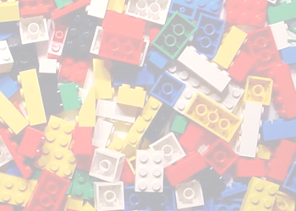

Let There Be Night needs legos!
Let there be night needs your 2 by 2 standard size legos to make a 3-D model of the light pollution in our community. Preferred colors are red, orange, yellow, green, blue, and purple. Your donations are greatly appreciated!! Thank you. ( please note that legos will not be returned, but will be donated to local charities and or schools.)

